Image | 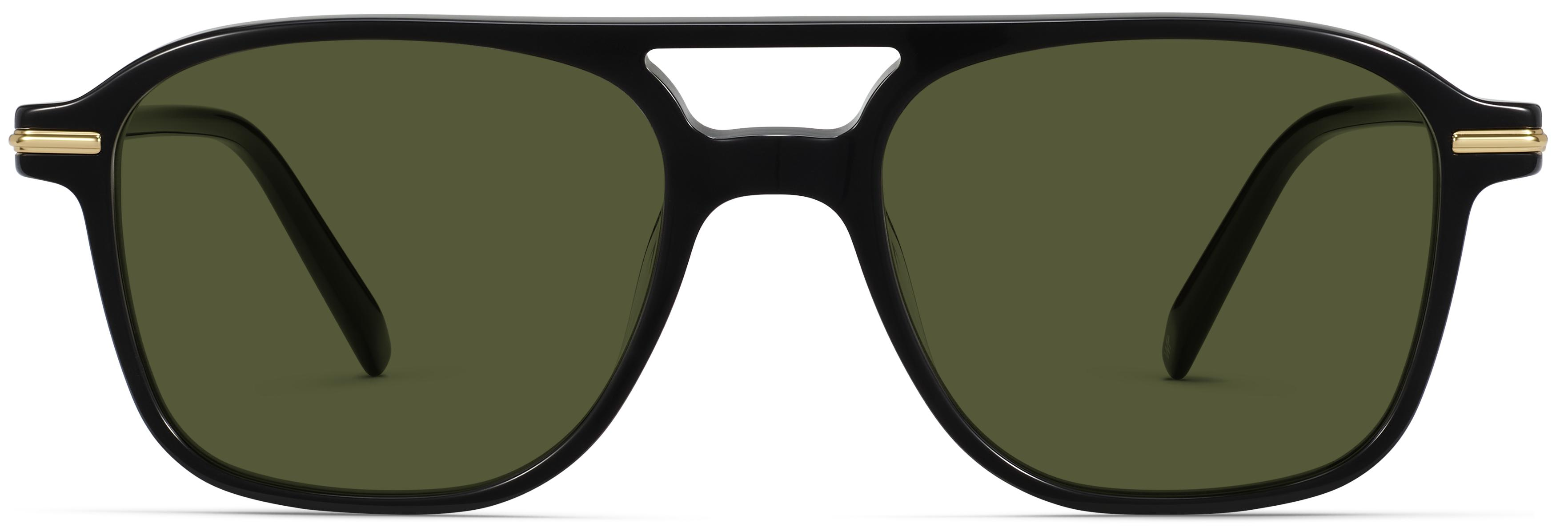
Brand | TOM FORD
Model Name | Brimmer
Price | RS 1450
PRODUCT DETAILS

